Assignment 1 - Create a Custom App Indeed.com

Step 1: Log in to the Org
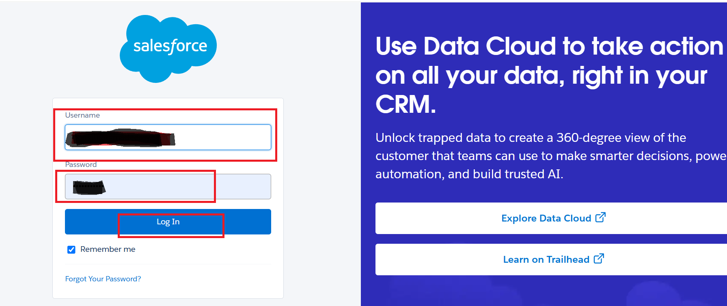
Step 2: Click on App Launcher (9 Dots)
Step 3: Find App Manager
Step 4: Select App Manager under the Apps section
Step 5: Select New Lightning App
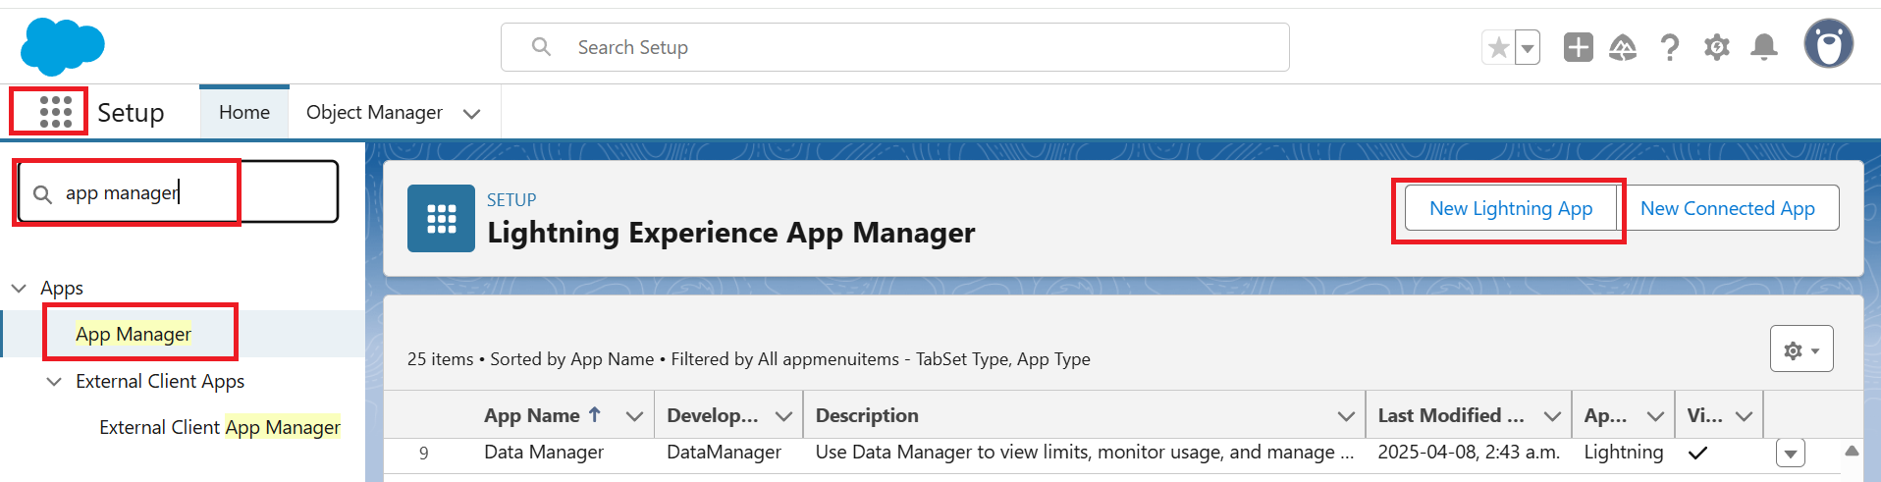
Step 6: Enter App Name (Indeed.com), Developer Name will be auto-populated
Step 7: Enter Description
Step 8: Upload App Logo under the Image section
Step 9: Click on the Next button
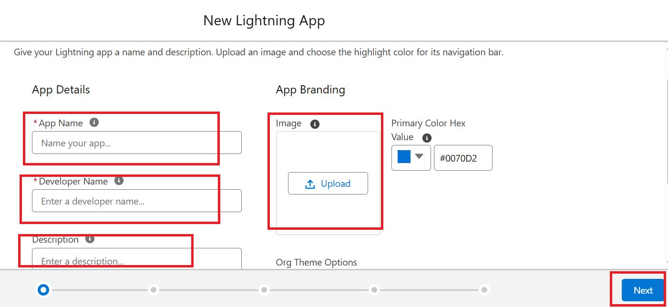
Step 10: Click on the Next Button
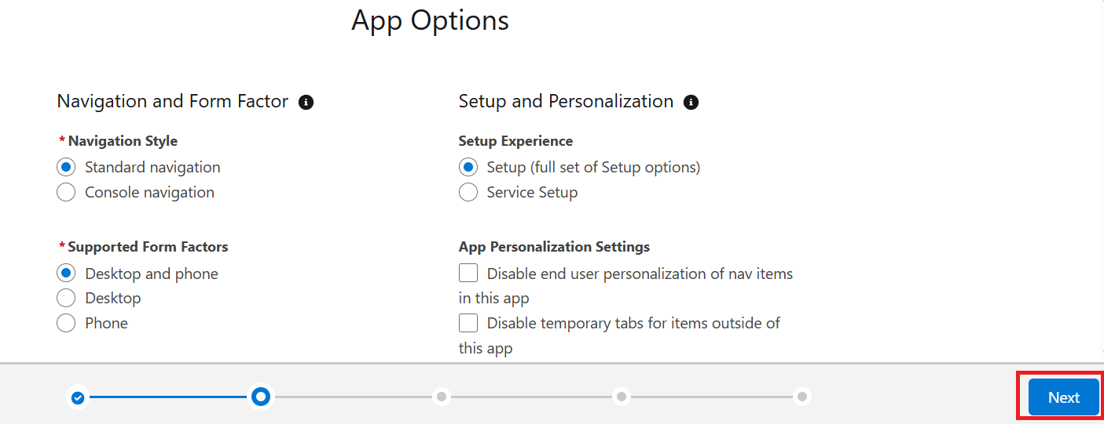
Step 11: Click on the Next Button
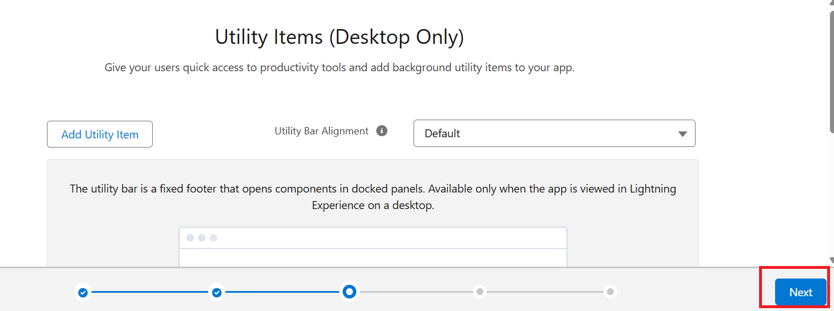
Step 12: Select Home and Reports Objects/Tabs/Buttons
Step 13: Click on the Next
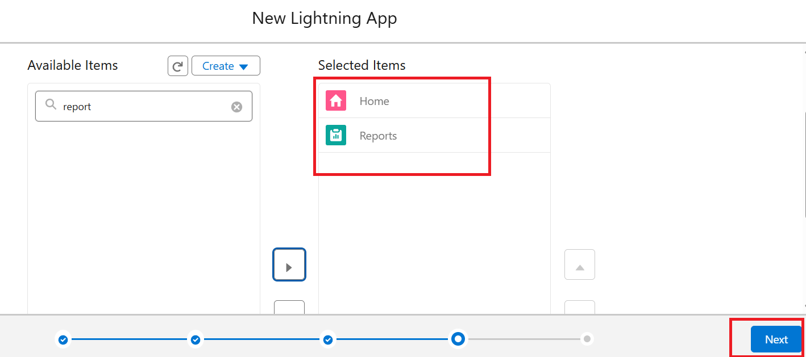
Step 14: Select all the Profiles from the Available profiles under the User profile section
Step 15: Click on the Save & Finish button
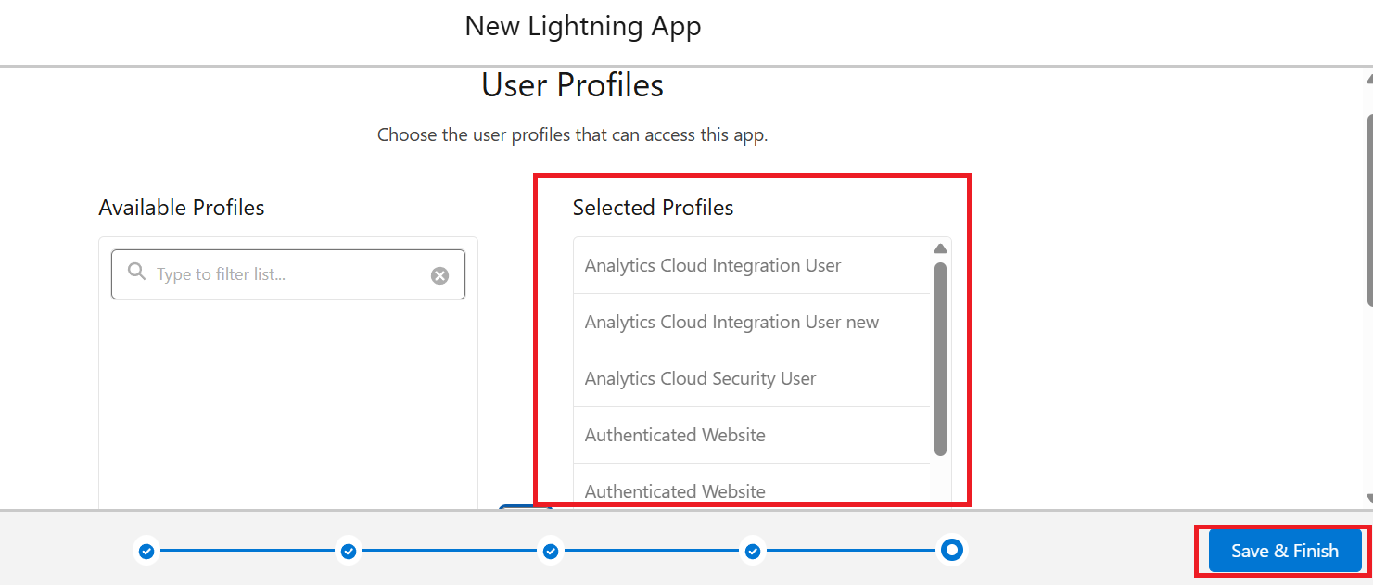
Custom App will be created

